**.classlist property**

This property is available to every node objects

Since classes are really very very important things to handle almost everything in the DOM tree.

So we developers mostly work with the classes

So it’s best to talk about this separately with a separate property

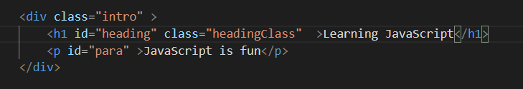

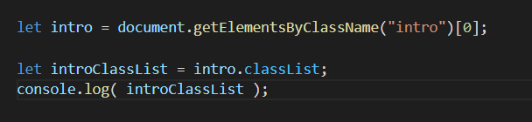

But all above things can also be done using .className property ?

What’s difference between the .className and .classList property ?

* Generally an HTML element can have more than one class
* So .classList will give us a DOMTokenList containing all of those classes
* So let say if a node has more than one class names than we will get themin string form which is very difficult to work with

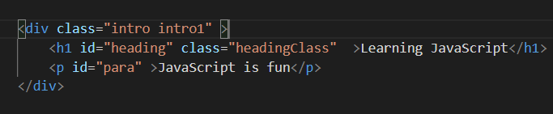

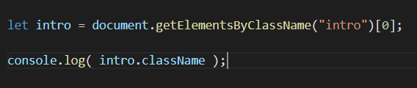

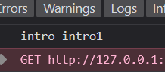

**DOMTokenList**

It is also just another numbered object ( so we can access the items like we do in arrays )

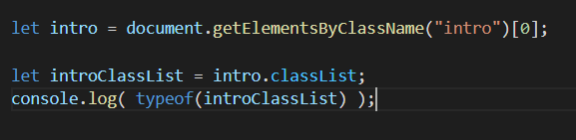

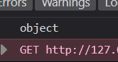

DOMTokelList object returned by .classList has some handy properties and methods

classList.add( ) 🡪 We can add a new class name

classList.remove( ) 🡪 We can remove the existing class name

classList.toggle( ) 🡪 We can toggle between the class names

classList.contains( ) 🡪 Boolean value depending on whether the classlist contains the specific class name or not

